ASSIGNMENT 1

**SMART HOME AUTOMATION WITH SENSORS USING**

**ARDUINO UNO**

**SOFTWARE COMPONENT:**

# TINKERCAD

**CIRCUIT DESIGN:**

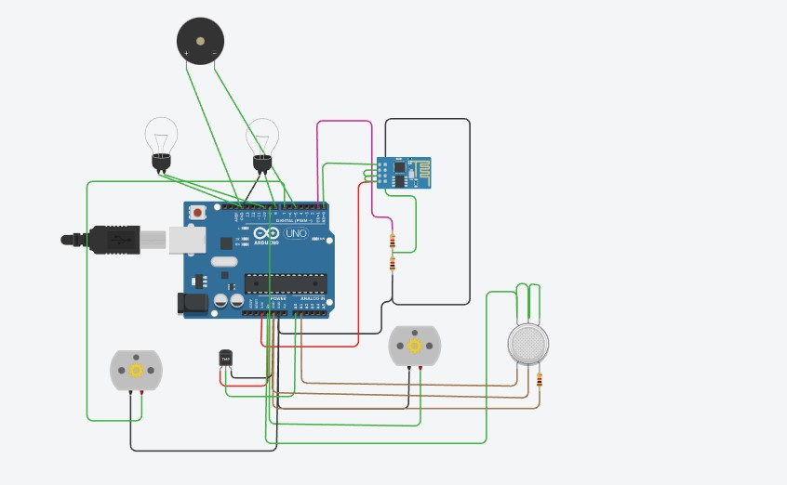

**CODE:**

void setup()

{ pinMode(A0, INPUT); pinMode(A1,INPUT); pinMode(9, OUTPUT); pinMode(8, OUTPUT); pinMode(7, OUTPUT); pinMode(10, OUTPUT);

Serial.begin(9600);

}

void loop() { int melody = 150;

int MQ2pin = A1;

while (1 != 0) {

int sensorValue = analogRead(MQ2pin);

if(sensorValue >= 200){ tone(5, melody) ; Serial.print(sensorValue);

Serial.println(" SMOKE DETECTED"); }else{

digitalWrite(5,LOW); Serial.print(sensorValue);

Serial.println("NO SMOKE DETECTED");

}

if (-40 + 0.488155 * (analogRead(A0) - 20) < 30) { if (-40 + 0.488155 * (analogRead(A0) - 20) < 20) { digitalWrite(9, LOW); digitalWrite(8, HIGH); digitalWrite(7, LOW); digitalWrite(10, HIGH);

} else { digitalWrite(9, LOW); digitalWrite(8, LOW); digitalWrite(10, HIGH); digitalWrite(7, LOW);

}

} else { if (-40 + 0.488155 * (analogRead(A0) - 20) > 30 && -40 + 0.488155 *

(analogRead(A0) - 20) < 40) { digitalWrite(9, HIGH); digitalWrite(10, LOW); digitalWrite(8, LOW); digitalWrite(7, LOW);

} else { digitalWrite(9, HIGH); digitalWrite(8, LOW); digitalWrite(7, HIGH); digitalWrite(10, LOW);

}

}

}

-40 + 0.488155 * (analogRead(A0) - 20); delay(10); // Delay a little bit to improve simulation performance }

**OUTPUT/SIMULATION:**

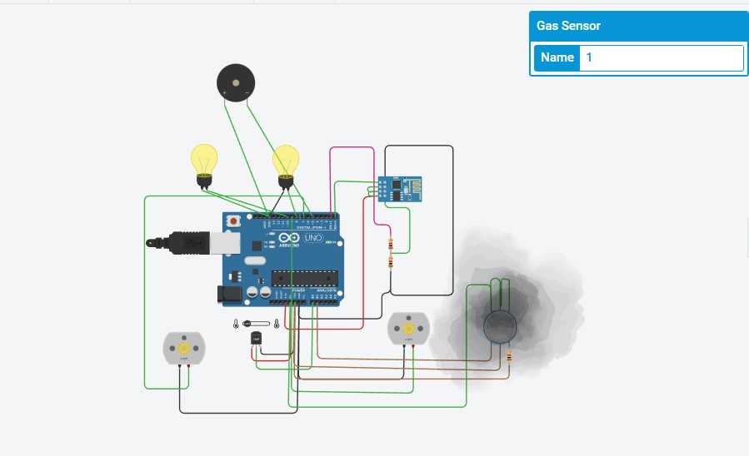

S.Preethy

953519205004